2024
Sonali Payment Gateway (SPG)

Sonali Bank PLC

[Integration with ETC System]
Powered by Sonali Bank PLC

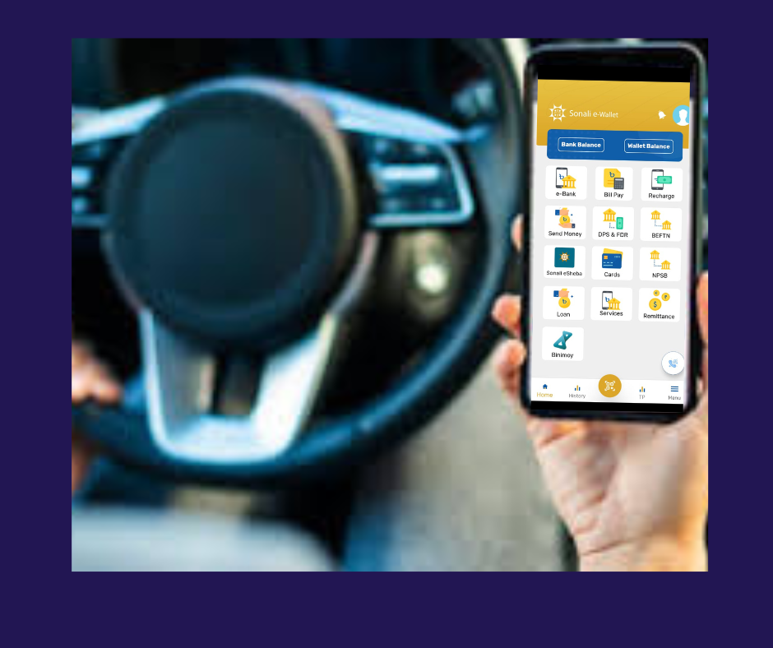
Summary:
This Integration document contains the information for collection of Toll with integration Bank. in this case we can define two ways
- prefund virtual wallet recharge by online payment gateway (sonali payment gateway)
- direct integration with bank account (sonali e-wallet)
Sonali Payment Gateway (SPG):- is online aggregator payment process portal , where service directly connect through API & web based re-direct and confirm payment, finally customer get proper response/services. Customer cans registration through web portal and recharge money at his virtual account through online. its open platform for any customer.
Sonali e-Wallet: - Sonali e-wallet is smart banking system, customer can registration through e-wallet and when a toll system send a payment request then sonali e-wallet confirm payment directly customer account.
Commitment of Services:
- Self Payment Service of Customers
- 24x7 services
- Online & sonali e-wallet
- API based Integrations
- Automatic Reconciliation
- Regular Settlement & confirm a-challan/ bank account next day
- Real time monitoring panel

Transaction Flow:
- Integration with Sonali payment gateway (SPG)
customer
1
4
SBL Toll Pay System
Sonali Payment Gateway
3
6
2
vehicle
ETC Toll System
5

##Steps of Flow Diagram
- online registration- web portal- any customer can registration through online & also can create a virtual account if they want , to make prefund of toll fee , also can recharge virtual account through online and counter .
- For registration sonali bank toll system call ETC toll system through API , also create virtual account at sonali bank.
- Customer send a virtual account recharge request through online using any popular payment channel as well as sonali bank any count (if customer recharge big amount recharge). Also customer claim request to refund money in his any bank account if he has un used amount.
- Sonali payment gateway take responsibility to facility to customer recharge amount through online.
- when vehicle pass through toll system – and ETC toll system send a request to Sonali bank payment confirmation. sonali bank Toll system verify request and confirm payment according to customer balance.
- ETC toll system send payment confirm request to Sonali bank system, if sonali bank confirm payment then pass the vehicle
- Finally t+1 sonali take reconciliation with ETC toll system last day transition and complete settlement. When settlement complete sonali bank send this money to ETC collection Bank account through BEFTN.

- Integration with Sonali e-Wallet:
customer
2
1
SBL Toll Pay System
Sonali e-Wallet
5
3

4
vehicle
ETC Toll System

##Steps of Flow Diagram
- Registration- sonali-ewallet customer can registration , to ensure balance to make toll payment by his sonali bank account through sonali e-wallet .
- Sonali e-wallet send registration request to ETC toll collection system through sonali bank toll collection system , when registration completed he can ready to toll payment.
- ETC toll collection system verify Sonali bank request for registration data and confirm registration to Sonali bank.
- when vehicle pass through toll system – and ETC toll system send a request to Sonali bank payment confirmation. sonali bank Toll system verify request and confirm payment according to customer balance.
- ETC toll system send payment confirm request to Sonali bank system, if sonali bank confirm payment then pass the vehicle
- Finally t+1 sonali take reconciliation with ETC toll system last day transition and complete settlement. When settlement complete sonali bank send this money to ETC collection Bank account through BEFTN.

Technical Strength of Sonali Bank PLC:
- High- Availability
- Load Balancers
- WAF
- REST API Integration
- Web based Applications
- Directly API based integrations

Technology of Integration and Reconciliation with ETC system:

- Registration and payment transaction through REST API
- Network connectivity (VPN/ IP white list)
- Reconciliation- by shared csv file shared by sftp through VPN network , sonali bank will provide SFTP system.
- daily fund settlement completed t+1 through BEFTN

Query of ETC:
SL# | Answer from sonali Bank PLC
01 | show on above description
02 | N/A
03 | maximum transaction process time 5-10 sec.
04 | t+1 after complete reconcile and settlement
05 | maximum sonali bank charge + ETC charge= 1.5
06 | ETC charge : 40% on
07 | only software integration so, no need any hardware
08 | - network connectivity ii) API integration iii) reconciliation & dispute process system
09

